Northern Schools’ Inter Counties Cross Country
Stewart Park, Middlesbrough, TS4 3SL
Saturday 5 February 2022 - Start: 1.00pm
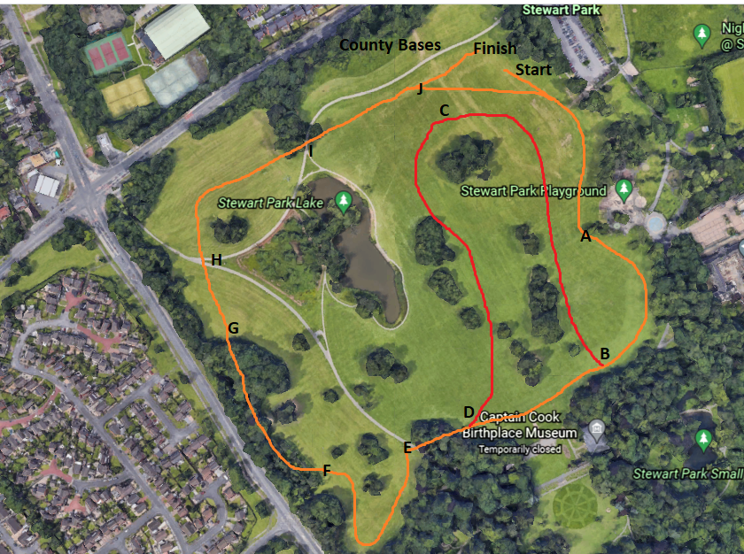
Race Info:
13:00 | Minor Boys | 2200m | 1 loop lap | START ABCDEFGHIJ FINISH
13:15 | Minor Girls | 2200m | 1 loop lap | START ABCDEFGHIJ FINISH
13:30 | Senior Boys | 6200m | 3 loop laps | START ABCDEFGHIJ x3 FINISH
13.50 | Senior Girls | 4000m | 1 lap + 1 loop lap | START ABDEFGHIJ ABCDEFGHIJ FINISH
14.15 | Junior Boys | 4000m | 1 lap + 1 loop lap | START ABDEFGHIJ ABCDEFGHIJ FINISH
14:30 | Junior Girls | 3500m | 2 laps | START ABDEFGHIJ x2 FINISH
14.50 | Inter Boys | 5800m | 1 lap + 2 loop laps | START ABDEFGHIJ ABCDEFGHIJ x2 FINISH
15.15 | Inter Girls | 4000m | 1 lap + 1 loop lap | START ABDEFGHIJ ABCDEFGHIJ FINISH

